

MSC Integration Service

May 2007

By Nagesh Chawla

Introduction

Marlborough Stirling Canada (MSC)’s suite of applications (MorWEB, Omiga, and Optimus) exchange mortgage and insurance information with various external parties such as credit bureaus, insurance companies, brokerage firms and lending institutions. The information exchange mechanism currently implemented is based on a point-to-point integration paradigm. This paradigm provides initial benefits such as easy understanding and quick implementation. However, as more and more external systems are connected, it results in several connections, making it hard to understand and even harder to maintain. While there are a few benefits, the drawbacks of this type of integration out-weigh the benefits. Therefore a loosely coupled integration architecture is an obvious choice. The current industry standard service-oriented architecture (SOA) provides loosely coupled integration paradigm. While there are several choices and supporting products to implement loosely coupled integration architectures, MSC’s choice is to implement a shared Integration Service for the MSC product suite based on Microsoft’s BizTalk Server 2006.

Microsoft BizTalk Server 2006

Today’s enterprise level applications are not islands. Applications rely on different processes provided by disparate systems internal and external to the enterprise. As organizations move towards service-oriented world to support enterprise level processes, creating effective business processes that unite disparate systems into a coherent-whole becomes a challenging goal. Microsoft BizTalk Server addresses this challenge. It supports loose coupling and Enterprise Service Bus (ESB) paradigm. BizTalk Server includes a range of technologies. The figure above illustrates major components of the product.

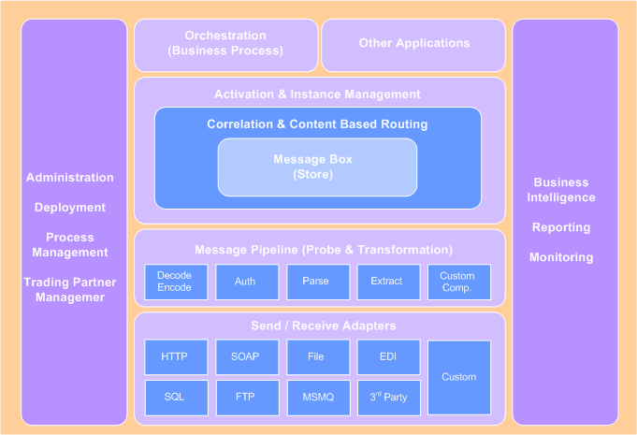
Figure 1: BizTalk Server 2006 Architecture Outline
The middle layer comprises the heart of the product and is called “messaging engine”. It provides the ability to communicate with a range of other software. It provides support for creating and running graphically-defined processes called “orchestrations”. Built on top of the engine’s messaging components, orchestrations implement the logic that drives all or part of a business process. Message box is central to the engine architecture, where all the messages are stored. On top of the store is a publish/subscribe engine. Applications subscribe for messages –based on the properties set for the message in the form of simple rules. It can accommodate a large number of routing rules (> 100K). The rules are also used for content-based routing of messages in message hub scenarios, thus providing hub-and-spoke model for b2b integrations. The pipeline components provide message probing and formatting along with encoding features. The product relies on various pluggable adapters for different kinds of communication. The engine can support a variety of protocols and data formats, including Web services and others. The product offers rich feature for partner management, administration and operation.

MSC Integration Service Philosophy
The core of MSC’s philosophy behind Integration Service is encapsulated in “loose-coupling”, which speaks to both technical and business audiences. This philosophy reflects efforts to integrate disparate systems and applications that involve the following:
- Deployment of applications that are often incompatible in terms of their capability to share data and interface process logic.
- Definition and creation of an ad-hoc schema common to the incompatible applications.
- Use of a specific transport protocol for interfacing application components to each other across a network or across the bus in a particular machine.
- Implementation of an intermediate layer of software adapters for exposing functionality of incompatible systems, translating objects and data shared by the systems, managing transfer of objects and data between the systems over appropriate protocols, and enforcing appropriate business rules in interactions between the systems.
The advantage of this approach is that it allows MSC to avoid rewriting existing external interfaces. As a result, it can eliminate the delay, cost, and trouble of rewriting one or more applications. Instead, the Integration Service would implement an adapter layer—usually a communication-gateway or format-translation program—that adapts the outputs of one application to the inputs of the other, and vice versa.
MSC Integration Service Solution

The MSC Integration Service is our vision that encapsulates the above philosophy that drives design principles for the solution. The solution architecture is illustrated in the figure below.

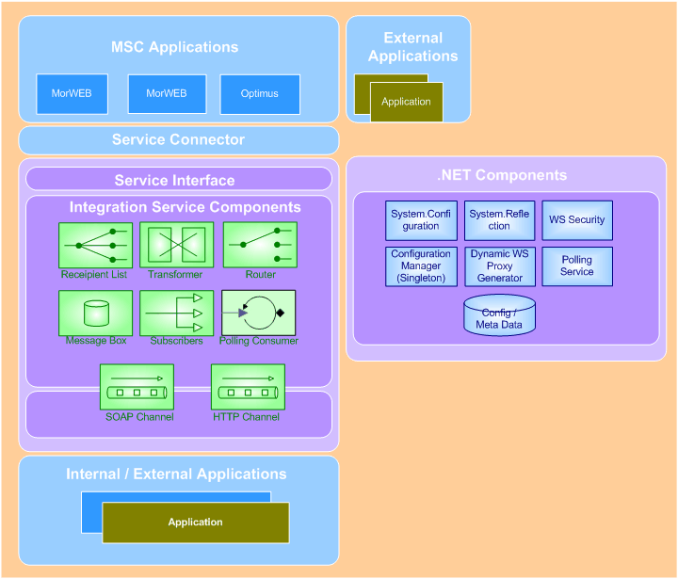
Figure 2: MSC Integration Service Architecture Outline

The principles for the architecture solution are as follows:

Synchronous and Asynchronous Communications
As the current business processes require response data from external systems to be available in order to continue processing in the same session, the request-response messaging is requried, that is the service would support synchronous process. However, the service would support asynchrnous messaging as well. This is implemented using the BizTalk ‘correlation’ feature.

Service Interface
As a shared service, it should be able to process requests from MSC’s internal applications. These applications are implemented in VB and the current protocol is XML/HTTP. In order to minimize changes and to keep protocol and service invocation logic out of the core business processing logic within the applications, service connector and servcie interface pattern is adopted.

Recipient List
Currently, each message is targetted towards one external system. This is achieved by point-to-point integration. However, to achieve loose-coupling, the service should be able to determine the recipient information at runtime and keep this information out of the request originating application. This functionality would be implemented using Recipient List pattern. Although, initial design would implement one recipient per request type (ex: credit bureau information etc.), the pattern facilitates extensibility to support multiple recipients model easily in future.

Transformation
When integrating an external system, usually the data is sent in a format which is required by the external system. The incoming data from request originating application should be transformed to external format or schema. The service would implement such functionality. Further, from the extensibility requirement view point, application of the transformation logic should be dynamic based on the recipient list. .NET framework’s reflection enables this functionality.

Communication
Different external systems may use different communication protocols. BizTalk supports various protocols by providing suitable adapters. However, the service should be able to determine the protocol required by the external system and use the appropriate adapter and channel. This would be implemented by having separate adapter ports in the BizTalk orchestration, that leverages hub-and-spoke model.

Common Data Interface
In the current business context space, the information exchanged between mortageg origination, insurance, lending systems are very similar. This means a generic message format at the request receiving end would benefit in terms of processing and extensibility. This eliminates different originating formats and allows us to introduce a message bus pattern in future amongst the applications.

Integration Service Roadmap

The service will evolve through a number of phased developments. This will enable us to accommodate learning curve involved with the new technology, identify risks and mitigate as we move along. The first go-live will be end of June, which is driven by AIG integration initiative.

Phase 1
This phase is to deliver AIG integration. This phase will accomplish the following from overall architecture stand point:

- Build Service Connector (ASP.NET application).
- Propose and layout first draft of CDI.
- Build CDI-AIG mapping in BizTalk.
- Build initial BizTalk orchestration that supports publish / subscribe messaging paradigm.
- Build early version of Configuration Manager based on XML configuration data.

Phase 2
This phase is to extend infrastructure components of overall architecture and migrate some of the current MorWEB integrations. This phase will accomplish the following:
- Extend CDI
- Extend Configuration Manager with configuration data hosted in database.
- Introduce branching for different adapters.
- Migrate current MorWEB integrations to the Service.

Phase 3
This phase is to extend further infrastructure components of the service and migrate some of the current integrations. This phase will accomplish the following:

- Extend the architecture to include dynamic WS proxy.
- Migrate current OMIGA integrations to the Service.

Phase 4
This phase is predominantly to convert OSG messaging mechanism into the service. This phase will accomplish the following:

- Converge and integrate Optimus Server Gateway (OSG) messaging mechanism.
- Migrate current Optimus integrations via OSG.

Summary

Currently MSC maintains point-to-point integrations with brokerage, lenders and insurance companies, which involve higher maintenance and development cost as the number of integrations grow. MSC envisioned an Integration Service that provides loose-coupling between MSC product suite and other internal and external systems, based on service-oriented architecture paradigm.

Integration Service is built on Microsoft BizTalk Server 2006, which provides middleware messaging platform. The product is based on SOA and ESB paradigms. This platform enables MSC to implement integrations relatively at a low cost and reduce maintenance as all existing integrations converge into the service.

A phased approach will be followed in converting existing integrations into Integration Service.

